LDAP Injection
# Source: AI Source: Provided by: [Data Path: Persons Table -> ID Column: 1, Name_En Column: Motasem Essam] -> From: [Chatgpt (GPT‑5 Mini)] on [1/20/2026]
LDAP Injection is a type of code injection attack that targets LDAP (Lightweight Directory Access Protocol) queries. LDAP is used in many applications to authenticate users or search directory services (like Active Directory).
If user input is not properly sanitized, an attacker can inject malicious LDAP code to:
- Bypass authentication
- Retrieve unauthorized information
- Modify or delete directory data

🧪 Simple Example of a Vulnerable Query
# Source: AI Source: Provided by: [Data Path: Persons Table -> ID Column: 1, Name_En Column: Motasem Essam] -> From: [Chatgpt (GPT‑5 Mini)] on [1/20/2026]
Suppose you have an LDAP query in pseudocode like:
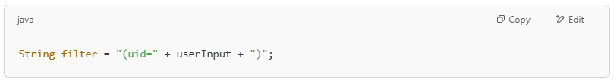
String filter = "(uid=" + userInput + ")";

If the attacker inputs:
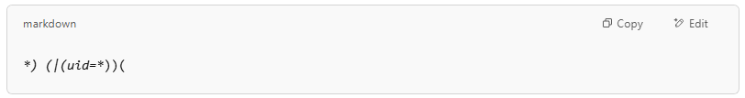
*) (|(uid=*))(

The final filter becomes: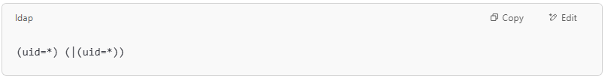
(uid=*) (|(uid=*))

🔓 This query matches all users, potentially bypassing authentication or exposing user data.

🧨 Authentication Bypass Example
# Source: AI Source: Provided by: [Data Path: Persons Table -> ID Column: 1, Name_En Column: Motasem Essam] -> From: [Chatgpt (GPT‑5 Mini)] on [1/20/2026]
Assume this is used in a login system:
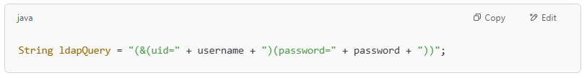
String ldapQuery = "(&(uid=" + username + ")(password=" + password + "))";

If username = *) (|(uid=*)) and password = anything, then the query becomes:
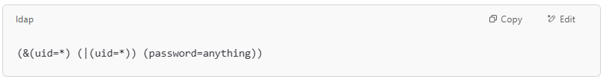(&(uid=*) (|(uid=*)) (password=anything))

This matches any user, allowing the attacker to log in without valid credentials.

🎯 What Can LDAP Injection Do?
# Source: AI Source: Provided by: [Data Path: Persons Table -> ID Column: 1, Name_En Column: Motasem Essam] -> From: [Chatgpt (GPT‑5 Mini)] on [1/20/2026]

Impact | Description
🔓 Bypass Login | Gain access without valid credentials
🔍 Unauthorized Access | Query or view hidden directory records
✏️ Data Modification | Change attributes or delete records (if permitted)

🔒 How to Prevent LDAP Injection
# Source: AI Source: Provided by: [Data Path: Persons Table -> ID Column: 1, Name_En Column: Motasem Essam] -> From: [Chatgpt (GPT‑5 Mini)] on [1/20/2026]

Technique | What It Does
✅ Input Validation | Only allow expected characters (e.g., alphanumerics)
✅ Use Parameterized LDAP APIs | Like DirContext.search() with SearchControls in Java
✅ Escape Special Characters | Escape characters like *, (, ), \, &, `
✅ Limit Query Scope | Use least-privilege accounts and define query limits
✅ Use Security Libraries | Frameworks with built-in protection or sanitization tools

🔐 Summary
# Source: AI Source: Provided by: [Data Path: Persons Table -> ID Column: 1, Name_En Column: Motasem Essam] -> From: [Chatgpt (GPT‑5 Mini)] on [1/20/2026]
Vulnerability | LDAP Injection
Affects | Directory services (e.g., Active Directory)
Caused by | Unsanitized input in LDAP queries
Risks | Login bypass, data theft, account takeover
Prevention | Input validation, escaping, safe APIs

